## Feasibility

<https://github.com/fhamborg/news-please>

[Giveme5W1H](https://github.com/fhamborg/Giveme5W1H)

## 

## Sum-up of the testing results:

Design requirement:

* Won’t interrupt their work flow too much
  + Don’t take up too much screen + foldable
  + A small chunk of core information by voice assistant at a time, unless asking for following up questions
  + Voice assistant for short answers, deep information on UI

A chrome extension which just takes a small section of the window and can be folded

Customizable automated streaming fact-checking feature

Information priority:

* (VUI+UI) Who did the fact-checking, the result of the fact-checking, what is the source information used in the fact-checking (brief) and who produced the source information
* (VUI+UI) Follow up question about the source information
* (UI) link to the fact-checking article and source information
* (UI) Relative news
  + With new perspectives (not similar content)
  + headline - highlighted sentences (like google search results)

## 

## Final Version

1.

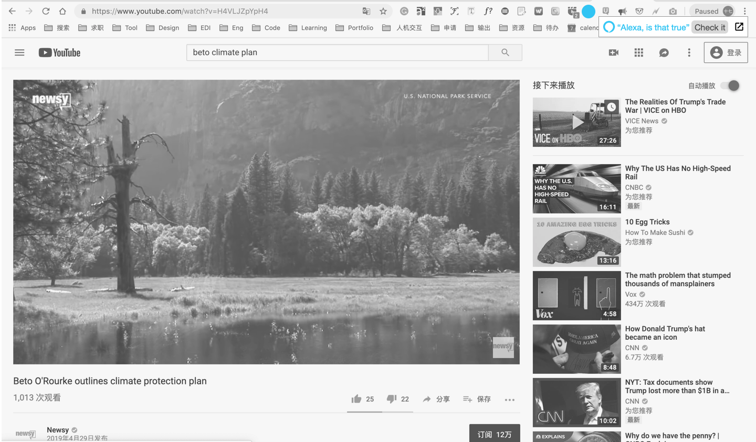

2.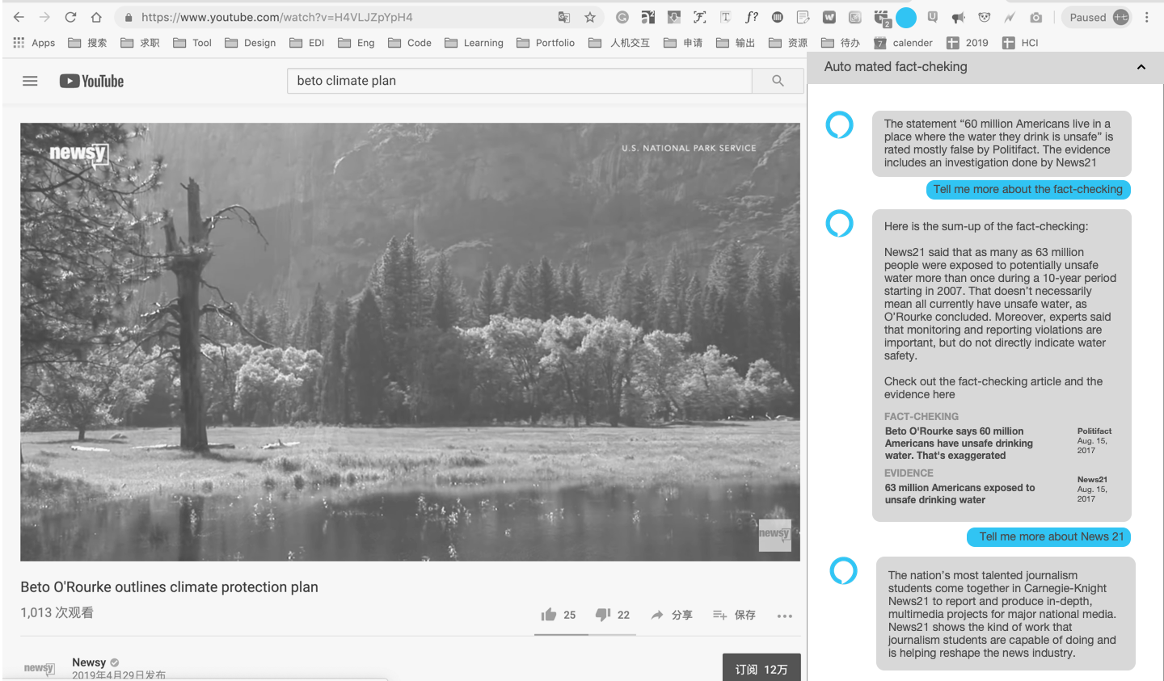

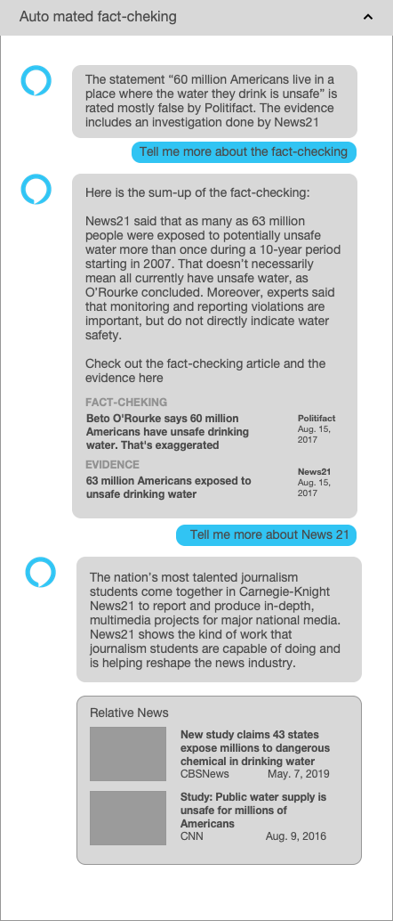

## Version 1

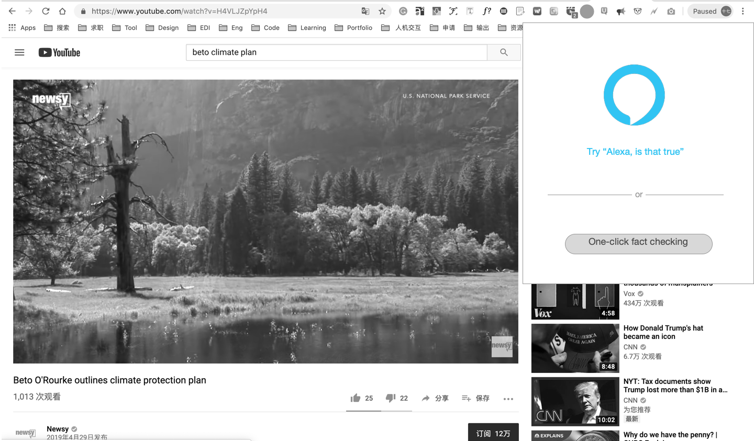

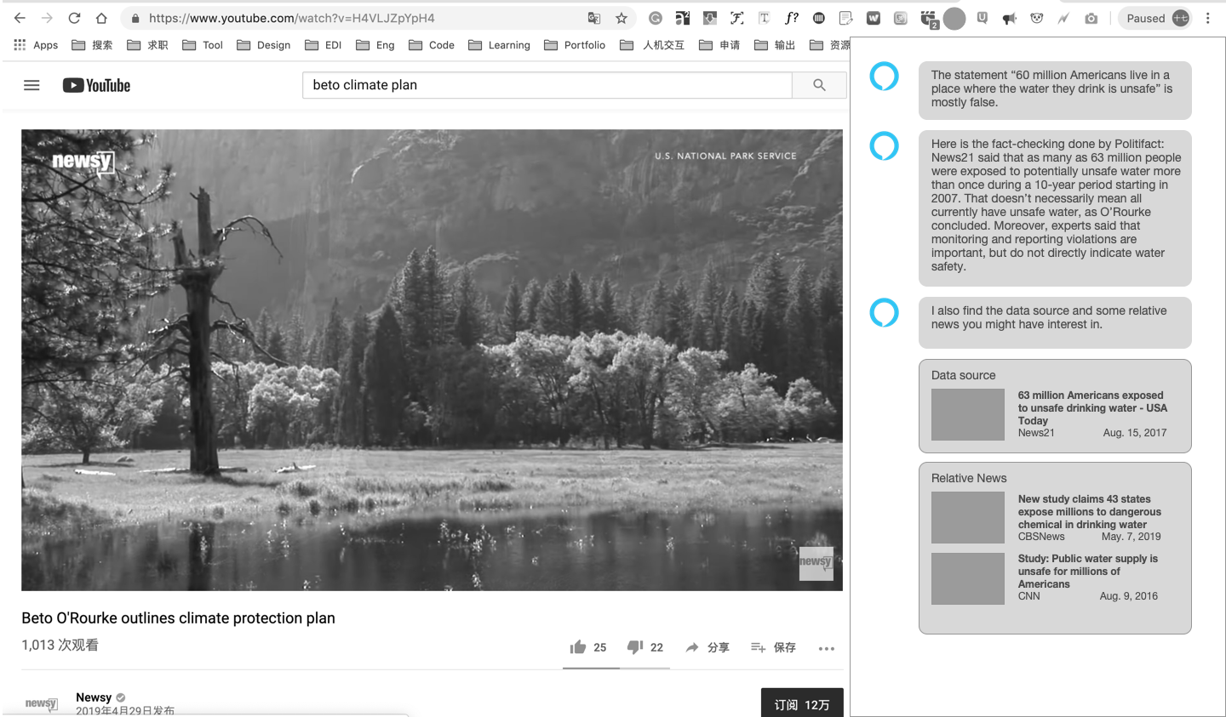

## Version 2

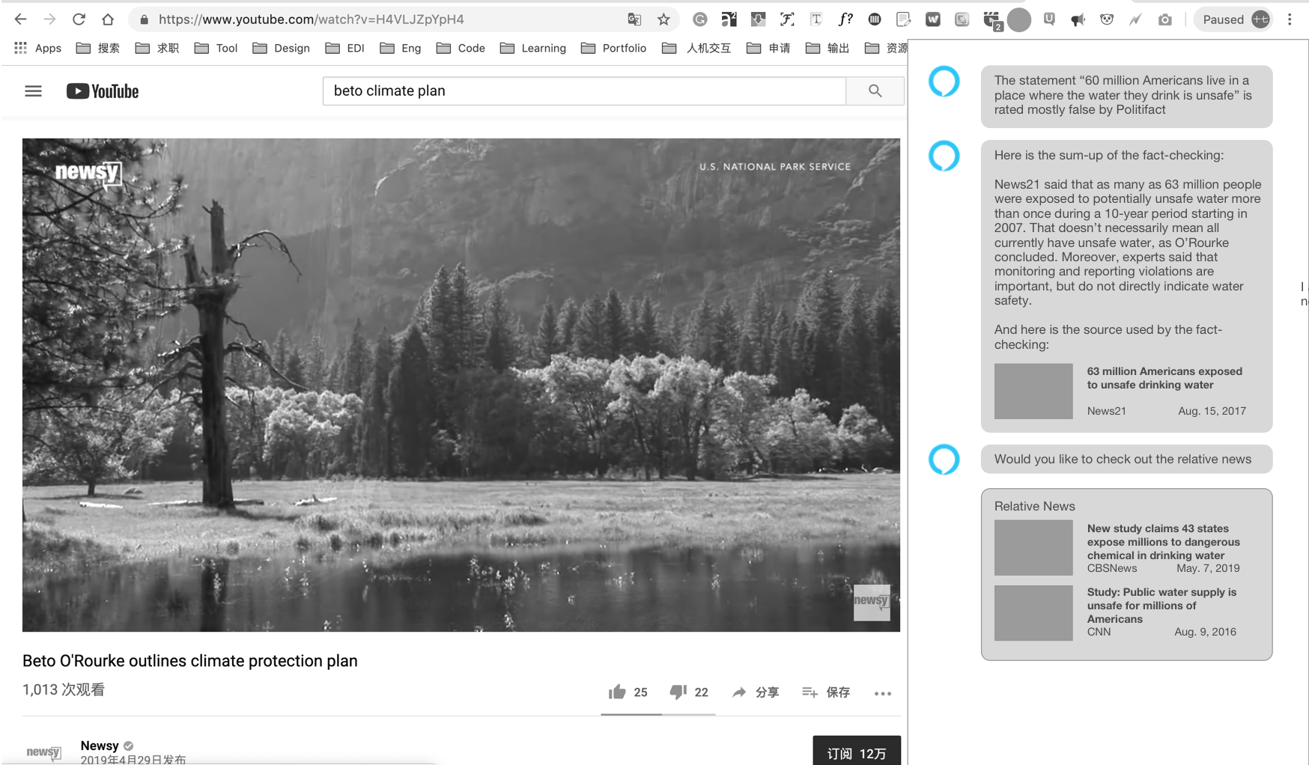

## Interviewee: Joanne(Siri user, listen news radio + read news)

* Like the sidebar / part-screen window, jumping to another website would break my workflow
* May not likely to do fact-checking while watching youtube or listening to the video, because the video/audio “flew out my mind very quickly” and “not sensitive to the facts”
* More likely to use it when it makes me realize there are so many fake news around and makes me more sensitive
* Would like a customizable pop-up feature:
  + It is beneficial that the app helps me know about the fact you don’t question about. But it pisses if it shows up all the time.
  + I would use the pop-up feature when I am doing research on a specific topic and want to make sure everything I learn is true. And it is kind of cool to have the pop-up in live political debate. Othertime, I prefer to ask for a fact-checking.
* Want to know who did the fact-checking
  + Personally, if I know the fact-checking is done by professional journalists, I would trust it.
  + Would like basic-info about who did the fact-checking and the source of the fact-checking article
  + For the data-source referred to in the fact-checking article, want to know who did the investigation and the basic info. For example, what is News 21. May get more info when hovering on the source name.
* Normally wouldn’t go into the relative news when in the middle of watching videos. I wouldn’t add the amount of things to read but it may be beneficial for journalists. Wouldn’t like to read the same thing with slightly difference in words. Might be interested in reading a new perspective (different opinions).
* Question about the algorithm.
  + Could it distinguish opinion and facts?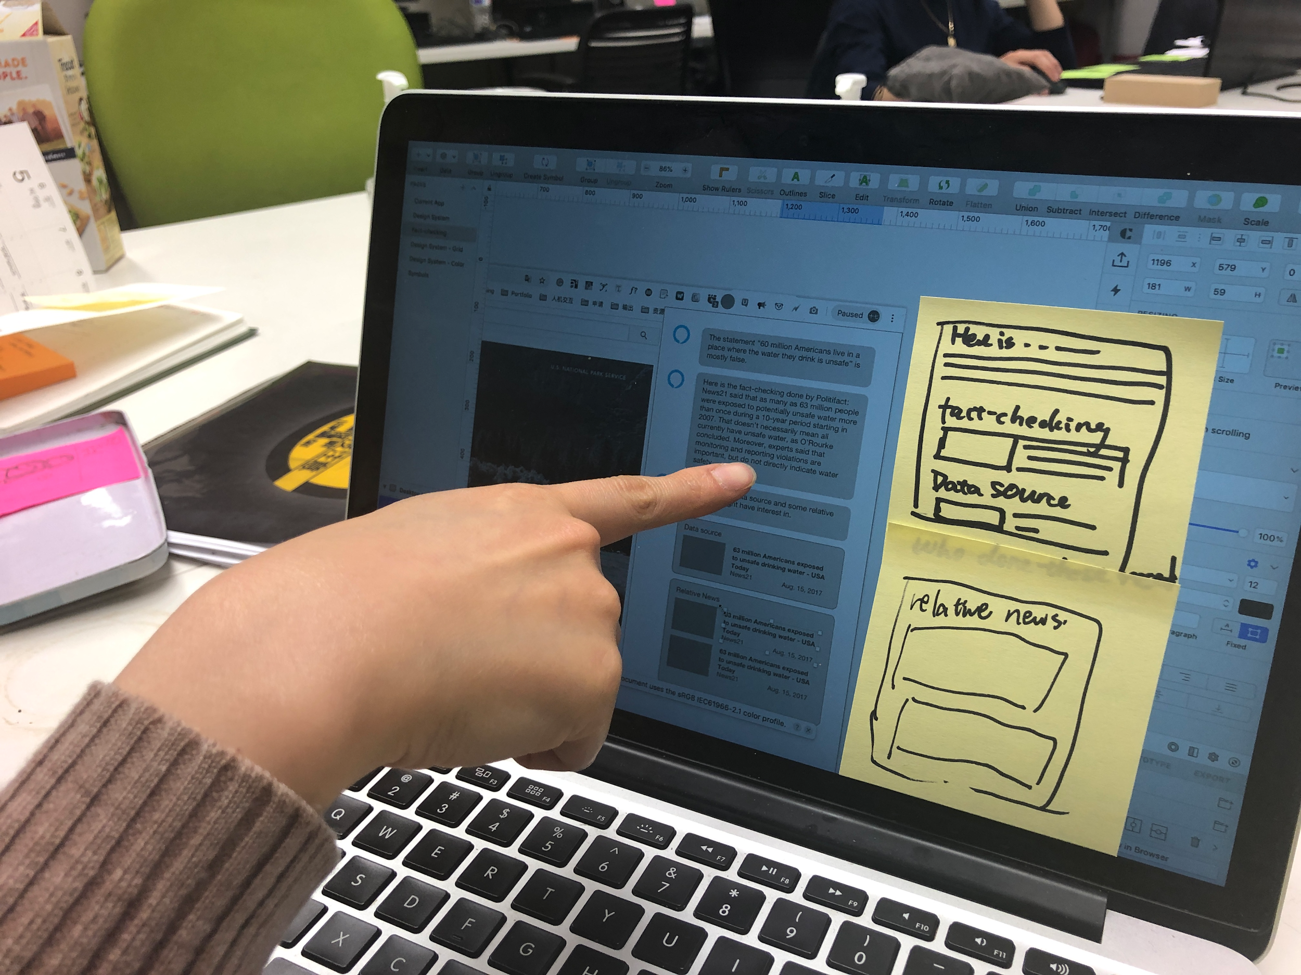

## Interviewee: Ming (Google-home user, watch news video + read news)

* Wish the window could be minimized, chose to show UI or not
* Don’t want to be interrupted too long while watching video
* Don’t want to hear the entire sum-up, just the source of evidence
  + Most of the time don’t want to click and really check the source the information.
  + Hope the assistant just do what be asked to do.
  + Would like to learn about the data source and relative news by following-up questions rather than
    - “Tell me more about the data source”
    - “Do you have other sources to back up the statement”
* Relative news is a too broad concept and a case-by-case thing. The source information for fact-checking is the most relative news.News might be relative from different aspects.
  + Eg, fake news of Trump & stock market on twitter. Want to know other funning fake news around trump just for fun
* Reading is much faster than listening. If I want relative news, I will search it rather than listen to the voice-assistant.